

Capstone Project Phase B

AttendEase

Attendance Tracking System

Project Number

24-2-D-4

Supervisor: Alexander Keselman

Amr Jarrar (Amr.Jarrar@e.braude.ac.il)

Deborah Dubinker (Deborah.Dubinker@e.braude.ac.il)

https://github.com/Jarrar7/ProjectA/

Table of Contents

Abstract 4

Chapter 1 – Introduction 5
1.1 Problem Statement 5
1.2 Existing Solutions 5
1.3 Proposed Solution 6
1.4 Stakeholders and Benefits 7

Chapter 2 – Background and Related Work 9
2.1 Objective 9
2.2 Existing Tools 9
2.3 Literature Review 11
2.4 Conclusion 11

Chapter 3 – Expected Achievements 13
3.1 Objectives 13
3.2 Expected Outcomes 13
3.3 Success Criteria 14
3.4 Challenges 14

Chapter 4 – Engineering Process 16
4.1 Process 16
4.1.1 Development Approach 16
4.1.2 Development Stages 16
4.1.3 Constraints 17
4.2 Product 18
4.2.1 Algorithms and Models 18
4.2.2 Implementation 18
4.2.3 Data Structure 19
4.2.4 User Interface 21
4.2.5 Use Case Diagram 22
4.2.6 Class Diagram 23
4.2.7 Activity Diagram 24
4.2.8 Functional Requirements 24
4.2.9 Non-Functional Requirements 25

Chapter 5 – Testing Plan 26
5.1 Testing Strategy 26
5.2 Unit Testing 26
5.3 Integration Testing 27
5.4 System Testing 28
5.5 Manual Testing 28

Chapter 6 – User Guide 30
6.1 Login Page 30
6.2 Student Dashboard / Teacher Dashboard 30
6.2.1 Course Details & Attendance Table – Student 31
6.2.2 Course Schedule Table – Teacher 32
6.2.3 Course Participants Table – Teacher 33
6.2.4 Messages 34
6.2.5 Calendar 36
6.2.6 Profile 36
6.3 Administration Dashboard 37
6.3.1 Manage Users 37
6.3.2 Manage Courses 39

Chapter 7 – Maintenance Guide 42
7.1 Link to GitHub 42
7.2 Installation 42
7.3 Running the Flask-Based Face Recognition Service 43
7.4 Libraries and Tools 43

References 44

Abstract

This document presents the Capstone Project Phase B for "AttendEase". Traditional attendance methods are often time-consuming, prone to errors, and easily manipulated. The attendance tracking system developed in this project provides an efficient and user-friendly solution for managing student attendance within educational institutions.
The system features role-based access for students, teachers, and administrators, with each user type having a tailored dashboard for interaction and management. Students and teachers can view course schedules, attendance statuses, and communicate through a secure messaging system. Teachers are provided with tools to upload photos for attendance documentation, while administrators have the ability to manage users and courses, ensuring the system’s smooth operation.
The backend is powered by Next.js for both frontend and API routes, with Supabase handling authentication and data storage. A Flask-based face recognition service allows for automated attendance tracking through image processing. This system integrates modern technologies such as React, Tailwind CSS, and various Python libraries, ensuring scalability and performance. The application is accessible through a web interface, providing easy setup through GitHub and detailed instructions for installation and maintenance.
This system aims to streamline attendance management, enhance communication, and provide administrators with efficient control over courses and user data, leveraging both AI and web technologies.

Chapter 1

Introduction

1.1 Problem Statement
In many educational institutions, tracking student attendance is a critical task that ensures students are attending their classes and helps in maintaining accurate records for academic and administrative purposes.
Traditional attendance methods, such as manual sign-in sheets or spreadsheet-based tracking, are often time-consuming, prone to human errors, and susceptible to manipulation. These methods can lead to inaccurate records, inefficiencies in tracking, and discrepancies in attendance reporting.
This creates a need for a more efficient, accurate, and reliable attendance tracking system.

1.2 Existing Solutions
Several solutions exist for automating attendance tracking, including:

- Biometric Systems: Biometric systems rely on unique physical characteristics like fingerprints or iris patterns to identify individuals. These systems are widely used for secure access and attendance tracking in various sectors.
- Pros:
  - Highly accurate when correctly calibrated.
  - Reduces chances of impersonation or proxy attendance.
  - Fast identification once the system is set up.
- Cons:
  - Requires physical contact or close proximity, which raises hygiene concerns, especially during pandemics.
  - Expensive to install and maintain.
  - May not work reliably if physical traits are altered (e.g., injuries to fingers or changes in iris visibility).

- RFID Systems: Radio-Frequency Identification (RFID) systems use tags or cards that students carry to record attendance. When a student scans their card at a reader, the system logs their presence.
- Pros:
  - Contactless and fast operation.
  - Easy to integrate with existing access control systems.
  - Cost-effective compared to biometric systems.
- Cons:
  - Cards can be lost, damaged, or intentionally swapped to falsify attendance.
  - Still requires students to actively scan their cards.
  - Limited to recording presence without additional data (e.g., timing or context).

- Manual Entry Apps: These apps allow teachers to manually record attendance on digital platforms, eliminating the need for paper-based records. For instance, apps like TeacherKit offer features to log attendance, track grades, and manage student behavior.
- Pros:
  - Simple and affordable to implement.
  - Digital logs reduce paperwork and ensure data is easier to store and retrieve.
  - Compatible with multiple devices, including smartphones and tablets.
- Cons:
  - Requires significant manual effort, which can be time-consuming.
  - Prone to human error during data entry.
  - Offers no additional security or accuracy benefits over traditional methods.

1.3 Proposed Solution
To address the limitations of traditional and existing automated attendance systems, we propose developing AttendEase, an advanced attendance tracking app that leverages facial recognition technology to deliver a seamless and efficient solution.

Core Features of the Solution:
- Facial Recognition Technology:
The app uses a sophisticated facial recognition algorithm to automatically identify students from a classroom photo. This involves:
- Capturing a photo of the class using a teacher’s device (e.g., a smartphone or tablet).
- Detecting and recognizing faces in the photo using a database of student photos linked to their IDs.
- Automatically marking attendance for the recognized faces.

- User-Friendly Interface:
The app is designed with intuitive interfaces tailored to each type of user:
- Teachers: Simplified process for capturing photos, reviewing attendance, and generating reports.
- Students: Access to attendance records and the ability to communicate with teachers regarding discrepancies.
- Administrators: Tools for managing user databases, and course databases.

- Real-Time Data Processing:
By employing client-server architecture and leveraging modern database solutions like Supabase, the app ensures:
- Instant synchronization of attendance records across devices.
- Secure storage and retrieval of data in real-time.
- Minimal processing delays, even for large classrooms.

Advantages of the Proposed Solution:
- Automation: Eliminates manual errors and reduces the time spent on attendance management.
- Accuracy: Achieves high reliability in identifying students, ensuring attendance records are accurate and fair.
- Scalability: Handles multiple classrooms and large student populations without performance degradation.
- Security: Implements robust encryption and data protection measures.

This solution not only streamlines attendance tracking but also enhances the overall management process for educational institutions, making it a valuable tool for teachers, students, and administrators alike.

1.4 Stakeholders and Benefits
- Students: Students are one of the primary beneficiaries of the attendance tracking system. By leveraging facial recognition technology, the system minimizes errors in attendance records and eliminates the need for manual interventions like signing sheets or remembering to carry RFID cards.
Key Advantages for Students:
  - Ensures their attendance is accurately recorded, reducing disputes over attendance errors.
  - Simplifies the attendance process, allowing them to focus on their studies without worrying about procedural hassles.
  - Provides transparency by allowing them to access their attendance records in real time through the app.
  - Enables communication with teachers via integrated messaging for clarifications on discrepancies.

- Teachers: Teachers play a pivotal role in ensuring the system is effective. The app significantly reduces the administrative workload involved in tracking and managing attendance.
Key Advantages for Teachers:
  - Automates the attendance-taking process, saving valuable classroom time.
  - Reduces paperwork, allowing teachers to focus more on teaching and less on administrative tasks.
  - Provides tools to generate detailed attendance reports effortlessly, enabling better monitoring of student participation.
  - Allows manual adjustments to attendance records in special cases, ensuring flexibility when needed.

- Administrators: Administrators require reliable attendance data for academic records. The system offers a centralized platform to manage attendance across the institution.
Key Advantages for Administrators:
- Facilitates institution-wide monitoring of attendance trends, enabling early identification of issues like absenteeism.
- Simplifies data management through a secure, centralized database that can be accessed and updated in real-time.
- Reduces the risk of errors or fraudulent activity, such as falsified attendance records.

- Institution: The educational institution as a whole benefits from an advanced, technology-driven attendance system that improves overall efficiency and transparency.
Key Advantages for Institution:
  - Enhances the institution’s reputation by showcasing its adoption of modern, innovative solutions.
  - Improves operational efficiency, reducing the need for manual record-keeping and error correction.
  - Provides valuable insights into attendance patterns, helping institutions take timely actions to address absenteeism.

Chapter 2

Background and Related Work

2.1 Objective
Attendance tracking applications have gained importance in educational institutions, offering enhanced efficiency and accuracy in monitoring student attendance.
Several existing attendance tracking tools provide partial solutions, but none fully address the combination of convenience, security, and accuracy that "AttendEase" aims to achieve.
In this literature survey, we explore existing tools and methods relevant to the development and functionality of our proposed attendance tracking app.

2.2 Existing Tools
- Iris Recognition Systems – Iris ID: Iris ID is a leading provider of iris recognition technology, widely used in various sectors for secure access and attendance tracking. Iris recognition systems are highly secure, as the iris pattern is unique to each individual and difficult to replicate.

How It Works: Iris ID systems capture high-resolution images of user’s irises, which are then compared to a database of stored iris templates to verify identity. The system registers attendance by matching the iris pattern of each student as they enter the classroom.

Pros:
  - High accuracy: Iris recognition is considered one of the most accurate biometric systems due to the uniqueness and stability of iris patterns.
  - Non-contact: Unlike fingerprint scanning, iris recognition does not require physical contact, making it hygienic and suitable for large groups.
  - Secure: It is difficult to spoof or replicate iris patterns, ensuring a high level of security for attendance data.

Cons:
  - Cost: Iris recognition systems are generally more expensive than other biometric methods, both in terms of installation and maintenance.
  - Environmental factors: The system's performance may be affected by lighting conditions or issues with the sensor quality.

Website: Iris ID

- Manual Entry Apps – TeacherKit: TeacherKit is a popular mobile app designed to help teachers manage classroom activities, including attendance tracking, grade management, and student behavior. It allows teachers to manually input attendance information for each class.

How It Works: Teachers use the TeacherKit app to create digital rosters for each class. They can quickly mark students as present, absent, or late with just a few taps on a mobile device. Attendance data is then stored and can be accessed at any time.

Pros:
  - Simplicity: TeacherKit is user-friendly and quick to set up, making it ideal for teachers who prefer a simple digital solution over paper-based attendance.
  - Cross-device compatibility: The app works on both iOS and Android devices, allowing teachers to use it on their smartphones or tablets.
  - Additional features: Beyond attendance, TeacherKit also offers features for grading, tracking student behavior, and generating detailed reports.

Cons:
  - Manual entry: Attendance is still entered manually by the teacher, which can lead to errors or inconsistencies if not carefully managed.
  - Limited automation: Unlike biometric or QR code-based systems, TeacherKit lacks automatic attendance recording, requiring teacher intervention to input data.

Website: TeacherKit

- Mobile-Based Attendance Apps – Classter: Classter is a comprehensive school management platform that includes a module specifically for attendance tracking. It offers a variety of tools for automating attendance and improving the overall classroom experience, including mobile-based solutions.

How It Works: Classter allows teachers to track attendance using multiple methods. Teachers can manually mark students as present or absent using the app’s user-friendly interface. Additionally, Classter supports automated attendance through QR code scanning, geolocation-based check-ins, and Bluetooth-based proximity detection.
- QR Code Attendance: Each class or event generates a unique QR code that students scan with their smartphones to automatically mark their presence. This system is efficient and minimizes the need for manual input from teachers.
- Geolocation-Based Check-Ins: Classter uses geolocation to verify student presence in the classroom. When students enter the designated area (e.g., the classroom), their location is detected, and attendance is automatically registered.
- Bluetooth Technology: The system can also use Bluetooth beacons to detect the presence of students' mobile devices as they enter the classroom. This proximity-based method ensures that attendance is accurately recorded without requiring students to manually interact with the system.

Pros:
- Flexibility: Classter supports multiple attendance tracking methods (manual, QR code, geolocation, Bluetooth), allowing schools to choose the most suitable option for their needs.
- Mobile-friendly: As a mobile-based platform, Classter enables teachers to take attendance from anywhere using their smartphones or tablets.
- Real-time updates: Attendance data is updated in real time, and teachers can generate reports on attendance trends and student participation.

Cons:
    - Dependence on technology: Automated methods (QR code, Bluetooth, geolocation) require students to have smartphones or devices with appropriate capabilities.
    - Requires infrastructure: To use features like Bluetooth or geolocation, schools need to implement the necessary infrastructure (e.g., Bluetooth beacons or geolocation zones).

Website: Classter

2.3 Literature Review
- Review of Biometric Systems for Attendance:
Ross, A., Nandakumar, K., & Jain, A. K. (2006). "Handbook of Multibiometrics." This book chapter reviews various biometric systems, including those used for attendance tracking, and discusses their advantages and limitations.

- Biometric Systems:
Jain, A. K., & Ross, A. (2008). "Introduction to Biometrics." This comprehensive overview discusses various biometric systems, including fingerprint and iris recognition, and their applications in attendance tracking.

- Facial Recognition Technology:
Zhao, W., Chellappa, R., Phillips, P. J., & Rosenfeld, A. (2003). "Face Recognition: A Literature Survey." This survey covers the development and application of facial recognition technologies, including their use in educational settings for automated attendance.

2.4 Conclusion
The proposed attendance tracking app aims to leverage facial recognition technology to address the limitations of existing attendance tracking methods. This approach will enhance the efficiency, accuracy, and user-friendliness of the attendance tracking process, benefiting all stakeholders involved. The system will help educational institutions manage attendance more effectively and improve overall student engagement.

Chapter 3

Expected Achievements

3.1 Objectives
In this project, we aim to create an advanced attendance tracking system that utilizes facial recognition technology to improve the accuracy and efficiency of the attendance process in educational institutions.
By automating the process of attendance marking, the system eliminates the potential for human error and reduces the administrative burden on teachers and staff.
Ultimately, this project aims to streamline the attendance management process, making it more efficient, secure, and accurate, while also providing an intuitive and accessible experience for all stakeholders involved.

3.2 Expected Outcomes
- Automated Attendance System: The system is designed to automate the attendance process by leveraging facial recognition technology. Teachers will upload photos taken during class, and the system will analyze these images to identify and match the students' faces with their stored records. This process ensures that attendance is automatically captured and recorded, minimizing manual intervention and increasing accuracy.

- User-Friendly Interface: The application will feature a user-friendly interface, allowing teachers to easily upload class photos, review the attendance records, and generate reports. The interface will be intuitive and streamlined, ensuring that teachers can quickly and efficiently manage the attendance process without extensive training.

- Database Integration: A robust database will securely store student photos, IDs, and attendance data, ensuring that all records are safely maintained and easily accessible. The system will use Supabase for database management, enabling seamless interaction with the frontend and ensuring data integrity.

- Real-Time Processing: Real-time processing capabilities will be incorporated to match faces captured in the uploaded photos with stored student records quickly. This ensures that attendance tracking is not only automated but also immediate, minimizing delays in processing and updating attendance data.

- Error Reduction: By using facial recognition, the system aims to significantly reduce errors compared to traditional attendance methods, such as manual roll calls or paper-based tracking. The accuracy of face matching will greatly enhance the reliability of the attendance records.

- Scalability: The system will be designed with scalability in mind, capable of handling large volumes of students across multiple classes. This scalability will ensure that the application can be used in various educational institutions, from smaller schools to large universities, without performance degradation.

3.3 Success Criteria
- Accuracy: The system aims to achieve a high level of accuracy, with a target recognition rate of at least 95% for student faces. This high accuracy ensures that the system reliably identifies students and minimizes the risk of false positives or missed attendance.

- Efficiency: In terms of efficiency, the attendance processing time should be kept under 2 minutes per class, ensuring that teachers can quickly upload photos and receive updated attendance records without delays. This fast turnaround time is crucial for maintaining the flow of class activities.

- User Satisfaction: The design of the user interface, the intuitiveness of the photo-upload process, and the overall experience of reviewing attendance will be evaluated to ensure that the system is accessible and efficient for all users.

- Scalability: The system should remain responsive and maintain its processing speed even when dealing with large volumes of student data, making it suitable for institutions of various sizes.

3.4 Challenges
- Facial Recognition Accuracy:
- Ensuring consistent accuracy across diverse student demographics and varying classroom conditions, such as lighting, camera angles, and occlusions.
- Customizing pre-trained models for specific environments and conditions, which can be resource-intensive and time-consuming.

- Data Privacy and Compliance:
- Managing sensitive biometric data like facial images while adhering to stringent data protection and privacy regulations.
- Implementing robust encryption techniques and secure storage protocols to prevent data breaches or unauthorized access.

- Scalability and Performance:
- Designing the system to efficiently handle increasing volumes of data, such as larger student populations and additional courses.
- Ensuring real-time face matching for hundreds of students across multiple classes without overloading the database or processing resources.

- User Accessibility and Compatibility:
  - Given the diverse range of devices and platforms used by teachers, students, and administrators, the system needed to be compatible with various operating systems, browsers, and hardware configurations.

Chapter 4

Engineering Process

4.1 Process

4.1.1 Development Approach
The development of the AttendEase followed a structured approach to ensure flexibility, efficiency, and adaptability. The key methodologies adopted were:

- Agile Methodology:
- Iterative Improvements: Develop the system in small, incremental cycles, enabling frequent evaluation and enhancement of features.
- Flexibility: Adapt quickly to evolving requirements or feedback from stakeholders, ensuring that the final product aligns with user needs.

The Agile approach allowed us to prioritize essential features, address challenges promptly, and deliver a functional product within the defined timeline.

- Incremental Development:
- Defining Clear Milestones: Setting specific goals for each development phase, such as user authentication, attendance management, and messaging functionality.
- Module Independence: Designing modules to function independently, reducing interdependencies and simplifying debugging and testing.
- Progressive Integration: Gradually integrating completed modules into a cohesive system, allowing for early identification and resolution of integration issues.

This strategy ensured that progress was measurable, risks were minimized, and each component was thoroughly tested before being added to the overall system.

4.1.2 Development Stages
- Requirements Gathering: Collecting detailed requirements from stakeholders to understand the specific needs and constraints.
- System Design: Creating detailed system architecture and design documents.
- Prototype Development: Developing an initial prototype to validate the core functionality.
- Iterative Improvement: Continuously improving the prototype based on user feedback.
- Final Implementation: Completing the development of all features and integrating them into a cohesive system.

4.1.3 Constraints
During the development of AttendEase, several constraints were encountered, including resource, technical, and operational limitations. Addressing these constraints was critical to ensuring the successful delivery of a robust and scalable attendance tracking system.

- Resource Limitations:
- Balancing development tasks within the constraints of available time.
- Prioritizing essential features while managing limited resources effectively.

- Technical Limitations:
- Overcoming limitations posed by the chosen technology stack, such as integration challenges or performance bottlenecks.
- Adapting to restrictions in existing infrastructure, including hardware compatibility and network constraints.

4.2 Product

4.2.1 Algorithms and Models
- Face Detection Algorithm: The system uses a hybrid approach for face detection, combining MTCNN (Multi-Task Cascaded Convolutional Networks) and Dlib’s CNN-based detector. MTCNN is the primary detector due to its speed and robustness, while Dlib's CNN detector serves as a backup when MTCNN fails. This ensures high accuracy in identifying face locations under various conditions, such as different orientations or lighting.

- Face Recognition Algorithm: For face recognition, the system utilizes FaceNet, implemented through the face_recognition library. After detecting a face, the system extracts facial embeddings and compares them against stored student records in the database. This deep learning-based approach evaluates the similarity between the detected and stored faces, ensuring precise identification.

- Pre-Trained and Custom Models: The face detection and recognition tasks rely on pre-trained models like MTCNN for detection and FaceNet for recognition, which are chosen for their high accuracy and ability to generalize across different environments. Additionally, the system supports fine-tuning these models using specific data collected from the educational environment, such as variations in student appearances, lighting, and camera angles. This customization helps improve the system’s performance and accuracy over time.

4.2.2 Implementation
- Frontend Implementation
- The frontend is developed using React and Next.js, ensuring a dynamic, responsive, and interactive user experience for teachers, students, and administrators.
- The interface is styled with Tailwind CSS, providing a modern and consistent design while enhancing usability.

- Backend Implementation
- The main backend is developed using Next.js API routes, which handle authentication, attendance tracking, and database interactions.
- The face recognition service runs separately using a Flask-based API. This service processes image uploads, detects faces, encodes them, and returns results via a RESTful API, ensuring smooth integration with the main system.

- Database Implementation
- Supabase serves as the primary database, managing student records, attendance logs, and facial embeddings.
- The system leverages real-time updates to ensure accurate attendance tracking based on facial recognition results, maintaining both efficiency and security.

4.2.3 Data Structure
- The attendance tracking system's data structure is built on a relational database hosted on Supabase.
- The schema is designed to ensure data consistency, scalability, and seamless integration with the system's frontend and backend components.
- It supports key functionalities such as user profiles, courses, class sessions, messaging, attendance tracking, and image uploads.
- Each table plays a vital role in maintaining the application's functionality and integrity.
- The following is a detailed breakdown of the database schema, outlining the tables and their respective fields.

Schema Overview:
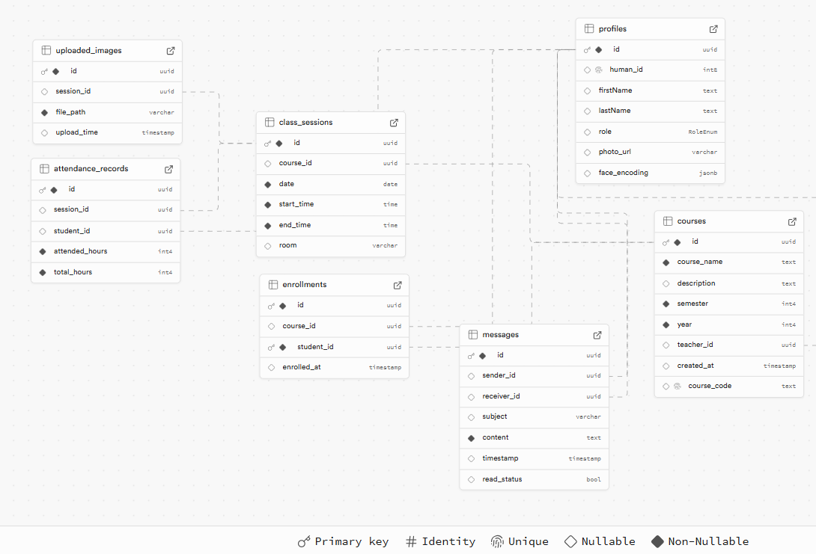

1. ‘profiles’ Table:
This table stores information about all users in the system.

Field Name | Data Type | Description
id | uuid (primary key) | User’s unique ID in the database
human_id | integer | User’s personal ID
firstName | text | User’s first name
lastName | text | User’s last name
role | RoleEnum | User’s role  (student, teacher, administrator)
photo_url | varchar | User’s photo

2. ‘courses’ Table:
This table manages the details of the courses in the system.

Field Name | Data Type | Description
id | uuid (primary key) | Unique ID of the course
course_name | text (non-nullable) | Name of the course
description | text | Description of the course
emester | integer (non-nullable) | The semester in which the course is taught
year | integer (non-nullable) | The year in which the course is taught
teacher_id | uuid | ID of the teacher assigned to the course
created_at | timestamp | Creation timestamp of the course record
course_code | text | Code of the course

3. ‘class_sessions’ Table:
This table logs individual class sessions for courses.

Field Name | Data Type | Description
id | uuid (primary key) | Unique ID of the class session
course_id | uuid | ID of the associated course
date | date (non-nullable) | Date of the class session
start_time | time (non-nullable) | Start time of the session
end_time | time (non-nullable) | End time of the session
room | varchar | Room where the session is held

4. ‘messages’ Table
This table facilitates messaging functionality for users.

Field Name | Data Type | Description
id | uuid (primary key) | Unique ID of the message
sender_id | uuid | ID of the user sending the message
receiver_id | uuid | ID of the user receiving the message
subject | varchar | Subject of the message
content | text (non-nullable) | Content of the message
timestamp | timestamp | Timestamp when the message was created
read_status | boolean | Indicates if the message has been read

5. ‘attendance_records’ Table
Tracks student attendance for class sessions.

Field Name | Data Type | Description
id | uuid (primary key) | Unique ID of the attendance record
session_id | uuid | ID of the associated class session
student_id | uuid | ID of the student
attended_hours | integer (non-nullable) | Hours the student attended
total_hours | integer (non-nullable) | Total hours of the session

- ‘enrollments’ Table
Tracks course enrollment information for students.

Field Name | Data Type | Description
id | uuid (primary key) | Unique ID of the enrollment record
course_id | uuid | ID of the course
student_id | uuid (non-nullable) | ID of the student
enrolled_at | timest | Timestamp of the enrollment

- ‘uploaded_images’ Table
Stores metadata for images uploaded during attendance tracking.

Field Name | Data Type | Description
id | uuid (primary key) | Unique ID of the uploaded image
session_id | uuid | ID of the associated clas session
file_path | varchar (non-nullable) | File path of the uploaded image
upload_time | timestamp | Timestamp when the image was uploaded

4.2.4 User Interface
The user interface (UI) of the attendance tracking system is designed to cater to the specific needs of different user roles: students, teachers, and administrators. Each interface is built for usability, ensuring a seamless and efficient experience.

- Student Interface
The student interface provides an intuitive platform for students to:
- View Attendance Records: Access their attendance history, including detailed logs of present, and absent statuses for each course.
- Send Messages: Communicate directly with teachers to clarify attendance discrepancies or seek further information.
- Review Feedback: Receive notifications and feedback related to attendance, class performance, or other updates from teachers.
The UI emphasizes clarity, offering students an easy way to stay informed about their academic engagement.

- Teacher Interface
The teacher interface is a robust toolset for managing attendance and course-related data. Key features include:
- Capturing Class Photos: Upload class photos for automated attendance processing using the face recognition system.
- Reviewing Attendance: Monitor daily attendance, validate detected attendance records, and make manual adjustments if necessary.
The interface is optimized for efficiency, enabling teachers to focus on their core responsibilities while maintaining accurate records.

- Administrator Interface
The administrator interface serves as a centralized dashboard for managing the system's overall functionality. Features include:
- Managing User Data: Add, edit, or remove user profiles (students, teachers, and administrators), ensuring accurate records across the database.
- Managing Course Data: Add, edit, or remove courses, assign teachers to courses, and manage course details, including schedules and enrolled students.
This interface is designed to provide administrators with actionable insights and full control over the system's operations.

4.2.5 Use Case Diagram
The Use Case Diagram illustrates the interactions between users (actors) and the system, highlighting the functionalities available to each actor
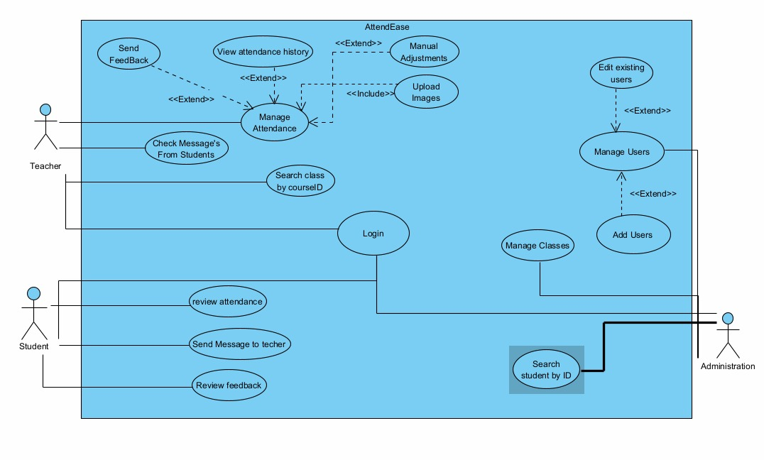
Figure 1: Use Case Diagram of AttendEase

4.2.6 Class Diagram
The Class Diagram outlines the system's structure, showing classes, attributes, methods, and relationships.
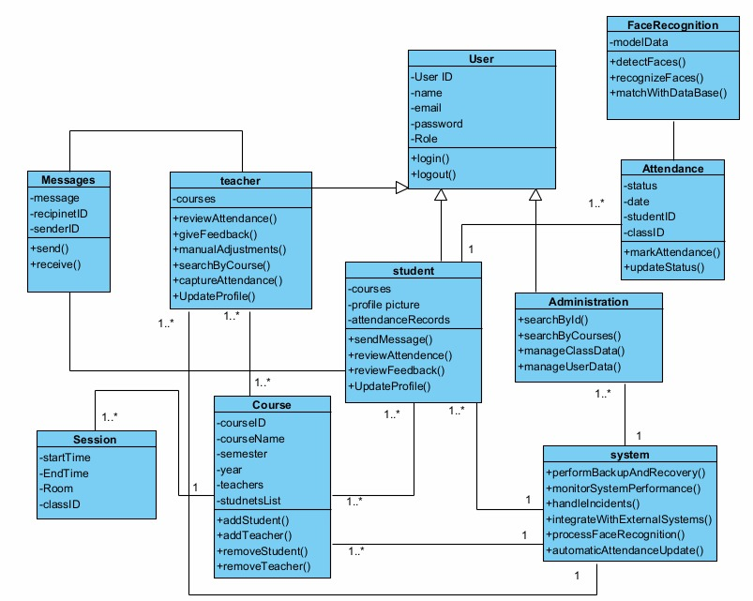
Figure 2: Class Diagram of AttendEase

4.2.7 Activity Diagram
The Activity Diagram represents the workflow of the attendance capturing process.
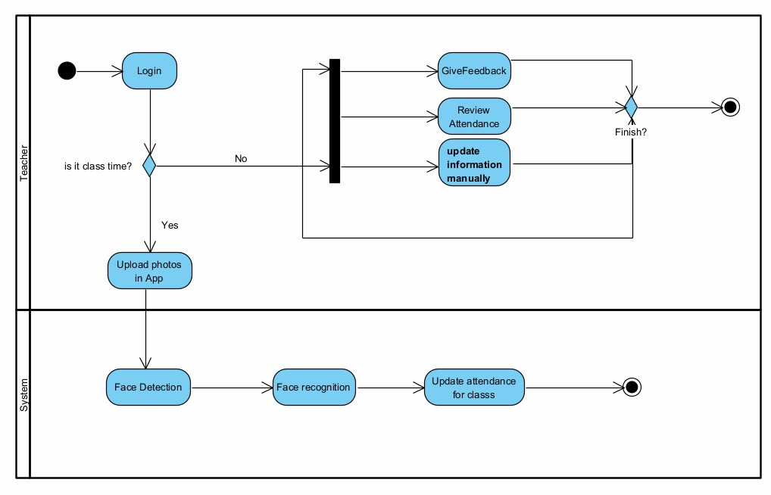
Figure 3: Activity Diagram of AttendEase

4.2.8 Functional Requirements
No. | Category | Who Can Do the Action | Description
1 | User Authentication | Teachers, Students, Administrators | The system must allow to log in using secure credentials.
2 | Data Management | Administrators | The system must allow to add, update, and delete users.
3 | Data Management | Teachers | The system must support uploading photos.
4 | Face Recognition | System (Automated) | The system must detect faces in the captured class photo.
5 | Face Recognition | System (Automated) | The system must recognize and match detected faces with the student database.
6 | Attendance Recording | System (Automated) | The system must automatically mark attendance based on face recognition results.
7 | Attendance Recording | Teachers | The system must allow to manually adjust attendance records if necessary.
8 | Attendance History and Reports | Students, Teachers, Administrators | The system must provide access to historical attendance records.
9 | Attendance History and Reports | Teachers, Administrators | The system must generate attendance reports for individual students, classes, and overall statistics.
10 | Messages | Students, Teachers | The system must allow to send and review messages and feedback.
11 | Backup and Recovery | System (Automated) | The system must automatically back up data to prevent loss.
12 | Backup and Recovery | System (Automated) | There must be a mechanism for recovering data in case of failure.

4.2.9 Non-Functional Requirements
No. | Category | Description
1 | Performance | The system must process and record attendance for a class of up to 50 students within 5 minutes.
2 | Performance | Support concurrent use by multiple teachers and classes without performance degradation.
3 | Scalability | The system must be scalable to handle up to 500 students per institution.
4 | Scalability | The system must be scalable to accommodate future growth in the number of students and classes.
5 | Usability | The user interface must be intuitive and easy to use for teachers, administrators, and students.
6 | Usability | The system must provide clear instructions and feedback to users.
7 | Security | The system must encrypt all sensitive data, including student photos and attendance records.
8 | Security | The system must include measures to prevent unauthorized access.
9 | Reliability | The system must have an uptime of at least 99.5%.
10 | Reliability | The system must handle errors gracefully and provide meaningful error messages to users.
11 | Maintainability | The system must be designed with modularity to facilitate updates and maintenance.
12 | Maintainability | The codebase must be well-documented to ensure ease of maintenance.
13 | Compatibility | The system must be compatible with various devices, including smartphones, tablets, and desktops.
14 | Compatibility | The system must support common web browsers (e.g., Chrome, Firefox, Safari).

Chapter 5

Testing Plan

5.1 Testing Strategy
The testing strategy for AttendEase is designed to ensure that the system meets all functional and non-functional requirements.
The testing process will follow a systematic approach, beginning with unit testing, followed by integration testing, system testing, and concluding with manual testing. Each phase is intended to identify and address potential issues, ensuring the system's reliability, scalability, and usability.

Testing Phases:
- Unit Testing: Testing individual components to ensure they work as intended.
- Integration Testing: Verifying that different modules work together seamlessly.
- System Testing: Ensuring the entire system functions as a cohesive whole.
- Manual Testing: Simulating real-world usage scenarios to uncover issues that automated tests may miss.

5.2 Unit Testing
Unit testing will focus on verifying the functionality of individual components and methods within the system. The goal is to catch and resolve issues at the earliest stage of development, ensuring that each component performs as expected in isolation.
Component | Test Case | Expected Result
User Login | Login with valid details | Login successful, user navigates to the main dashboard
User Login | Login with invalid details | Login failed, error message displayed
User Profile | Update user profile with valid details | Profile updates successful, changes reflected in the database
User Profile | Update profile with invalid details | Update failed, error message displayed
View Reports (Student) | View attendance history | Attendance history displayed correctly
View Reports (Teacher) | View class attendance | Attendance records displayed correctly
View Reports (Administrator) | View overall attendance | Overall attendance data displayed correctly
Data Management (Administrator) | Manage user data with valid user ID | User data updated successfully
Data Management (Administrator) | Manage user data with invalid user ID | Update failed, error message displayed
Data Management (Administrator) | Manage class data with valid class ID | Class data updated successfully
Data Management (Administrator) | Manage class data with invalid class ID | Update failed, error message displayed
User Registration (Administrator) | Register a new user with valid details | Registration successful, user data stored in database
User Registration (Administrator) | Register a new user with invalid details | Registration failed, error message displayed
Users Management (Administrator) | Remove user with valid user ID | Student removed successfully from class
Users Management (Administrator) | Remove user with invalid user ID | Removal failed, error message displayed
Attendance Record Management | Mark attendance with valid details | Attendance marked successfully, records updated in the database
Attendance Record Management | Mark attendance with invalid details | Attendance marking failed, error message displayed
Attendance Record Management | Update attendance with valid details | Attendance updated successfully
Attendance Record Management | Update attendance with invalid details | Attendance update failed, error message displayed
Capture Attendance | Capture attendance with valid class ID | Attendance captured successfully, records updated in the database
Capture Attendance | Capture attendance with invalid class ID | Attendance capture failed, error message displayed
Face Recognition | Process face recognition with valid photo | Face recognized successfully, attendance records updated
Face Recognition | Process face recognition with invalid photo | Face recognition failed, error message displayed

5.3 Integration Testing
Integration testing focuses on verifying the interactions between different modules of the system. The goal is to ensure that the modules, when combined, function as intended.

Test Case | Modules Involved | Expected Result
User Login and Dashboard | User Authentication, Dashboard | Successful login should redirect the user to the correct dashboard based on their role (teacher, student, administrator).
Attendance Capture and Face Recognition | Face Detection, Face Recognition, Database | Successfully captured attendance should trigger the face recognition module, which updates attendance records in the database.
User Interface Interaction | UI, Backend APIs | All user interface actions (e.g., button clicks, form submissions) should correctly interact with backend APIs and reflect changes in the UI.

5.4 System Testing
System testing ensures that the entire system meets the specified requirements and functions as a complete, integrated application.

Test Case | Description | Expected Result
Full System Workflow | Simulate a complete attendance capture process from login to displaying the attendance in the users’ dashboard | The system should successfully handle the entire workflow without errors, accurately capturing attendance and displaying it for the relevant users.
Performance Testing | Test system performance under maximum load (e.g., 500 students across multiple classes) | The system should remain responsive and complete tasks within the performance criteria specified in the non-functional requirements.
Security Testing | Test system security features, including login, data encryption, and access control | The system should enforce all security measures, preventing unauthorized access and securely handling all data transactions.
Data Recovery Testing | Simulate a system crash and test data recovery procedures | The system should successfully recover data from backups without loss.
Cross-Platform Compatibility | Test system on different devices (desktop, tablet, smartphone) and browsers | The system should function correctly across all tested platforms and browsers, maintaining usability and performance.

5.5 Manual Testing
Manual testing simulates real-world user scenarios to identify issues that automated tests might miss. This testing is crucial for ensuring that the user interface is intuitive and that the system behaves as expected under various conditions.

Test Case | Scenario | Expected Result
Teacher Interface Navigation | Teacher navigates through the dashboard, and captures attendance | All actions should be smooth, with clear feedback and no unexpected errors or delays.
Student Profile Update | A student attempts to update their profile information | The system should allow updates, show confirmation, and reflect changes in the database.
Error Handling | Enter incorrect data in forms (e.g., invalid class ID during attendance capture) | The system should display meaningful error messages and guide the user to correct the input.

Chapter 6

User Guide

6.1 Login Page
- The login page allows students, teachers, and administrators to securely access the system. Only users with existing accounts can log in.

- Each user logs in using their email and password.

- After logging in, users will be directed to a dashboard specific to their role:
- Students will be directed to the Student Dashboard.
- Teachers will be directed to the Teacher Dashboard.
- Administrators will be directed to the Admin Dashboard.

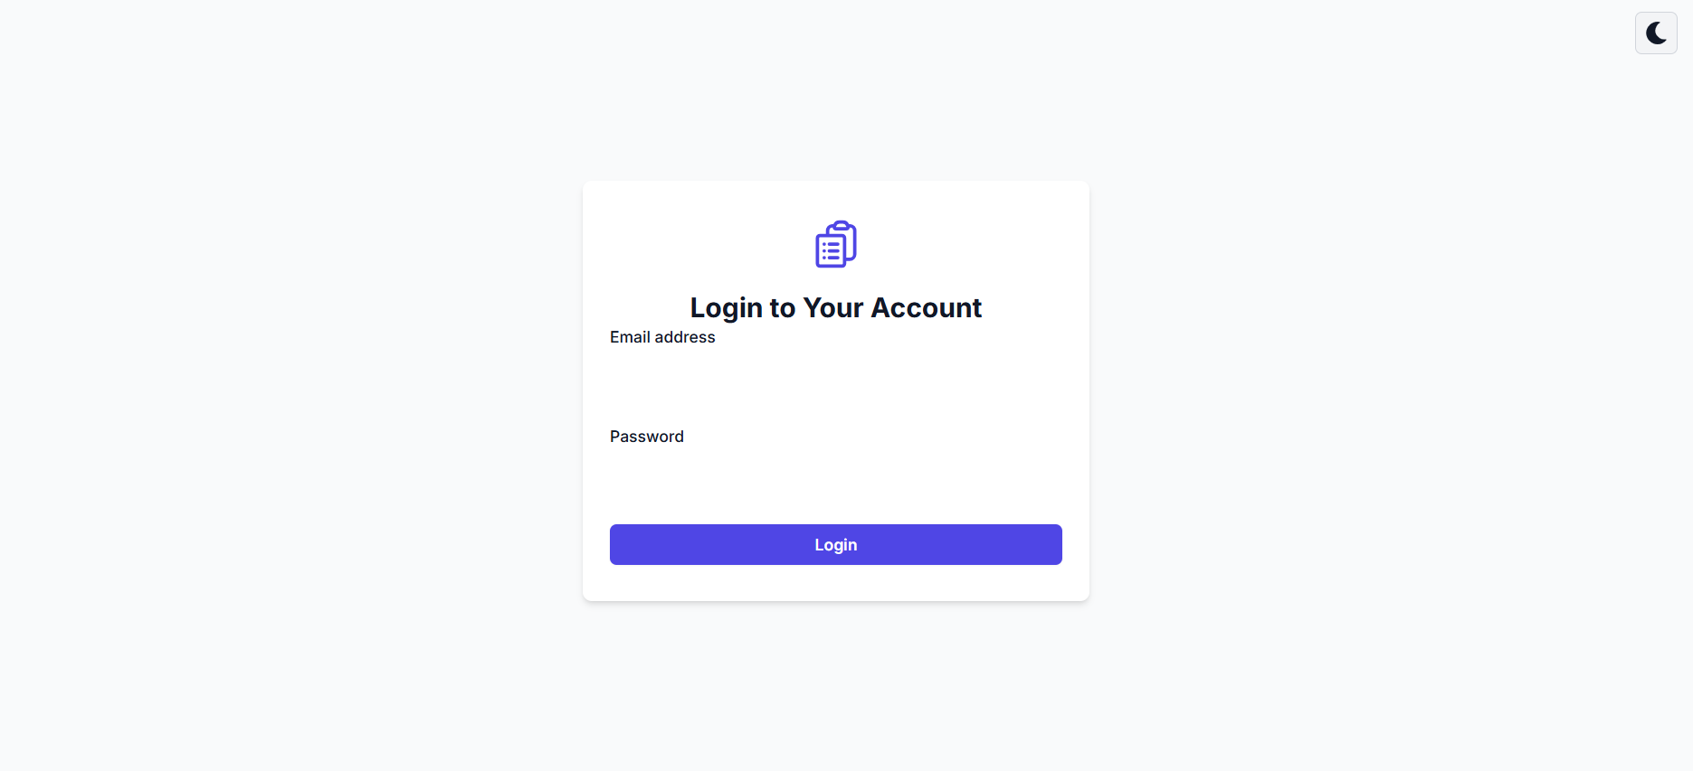

6.2 Student Dashboard / Teacher Dashboard
- Once logged in, the administrator is directed to the Student Dashboard / Teacher Dashboard.

- The dashboard displays a list of all the courses the student / teacher has in the database.

- The student / teacher can switch to current courses or courses taken / taught in previous semesters or years (a dropdown menu allows the student / teacher to select past semesters/years and view their course history).

- The Student Dashboard / Teacher Dashboard also include the following tabs:
- Messages
- Calendar
- Profile

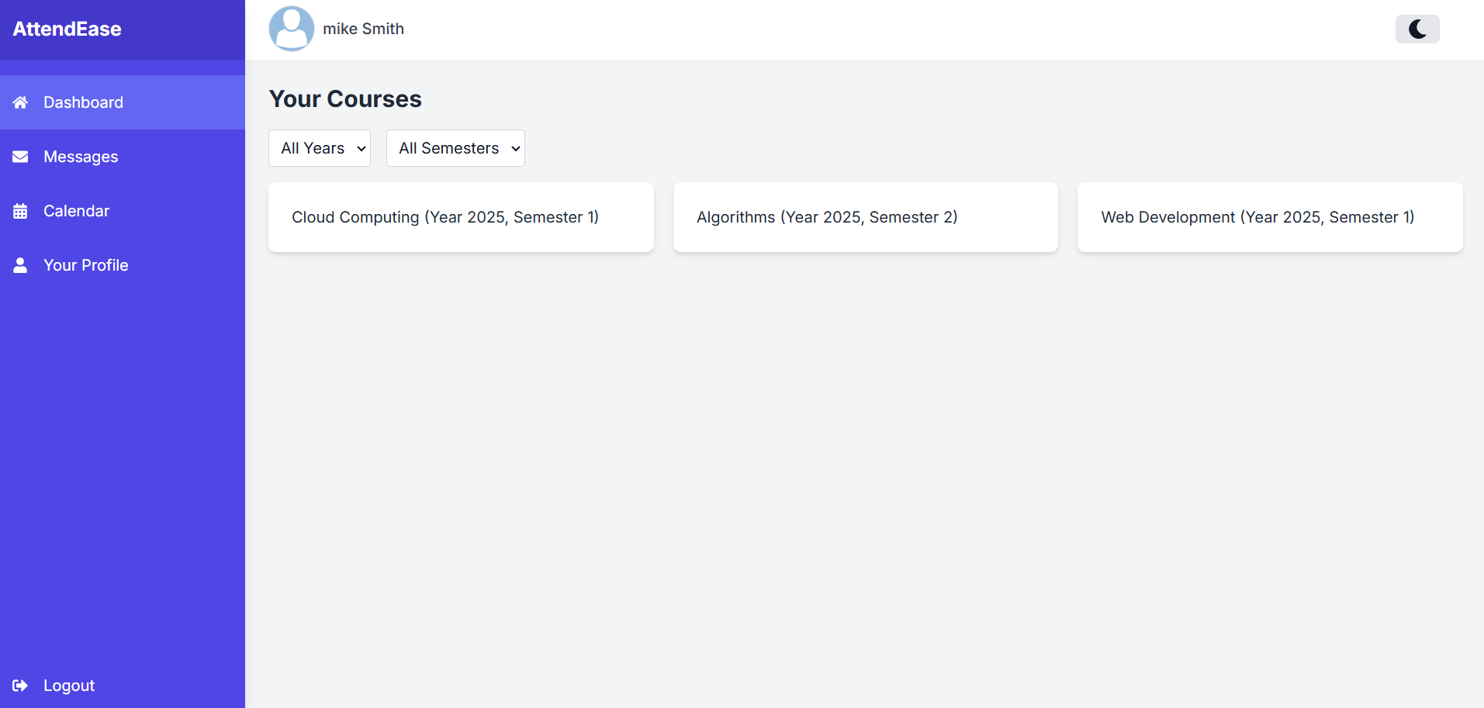

6.2.1 Course Details & Attendance Table – Student
- Once the student clicks on a specific course, they will see a table listing all the lectures for that course.

- Each row in the table represents a lecture, displaying the following information:
- Date: The date of the lecture.
- Hours: The time (duration) of the lecture.
- Room: The location where the lecture was held.
- Attendance Hours: Number of hours a student attended the lecture.
- Total Hours: Total hours of the lecture.

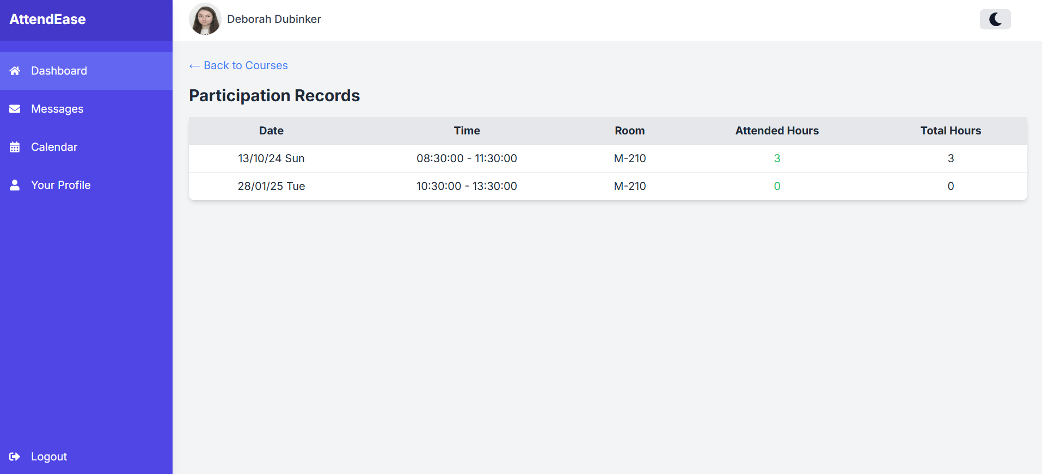

6.2.2 Course Schedule Table – Teacher
- Once the teacher clicks on a specific course, they can see two tables: Course Schedule Table and Course Participants Table. In the Course Schedule Table there are details for each lecture, including:
  - Date: The date of the lecture.
  - Hours: The time (duration) of the lecture.
  - Room: The location where the lecture was held.

- Upload Photo: In each row of the table, there is an option for the teacher to upload photos of the class for that particular lecture (for attendance tracking and documentation).

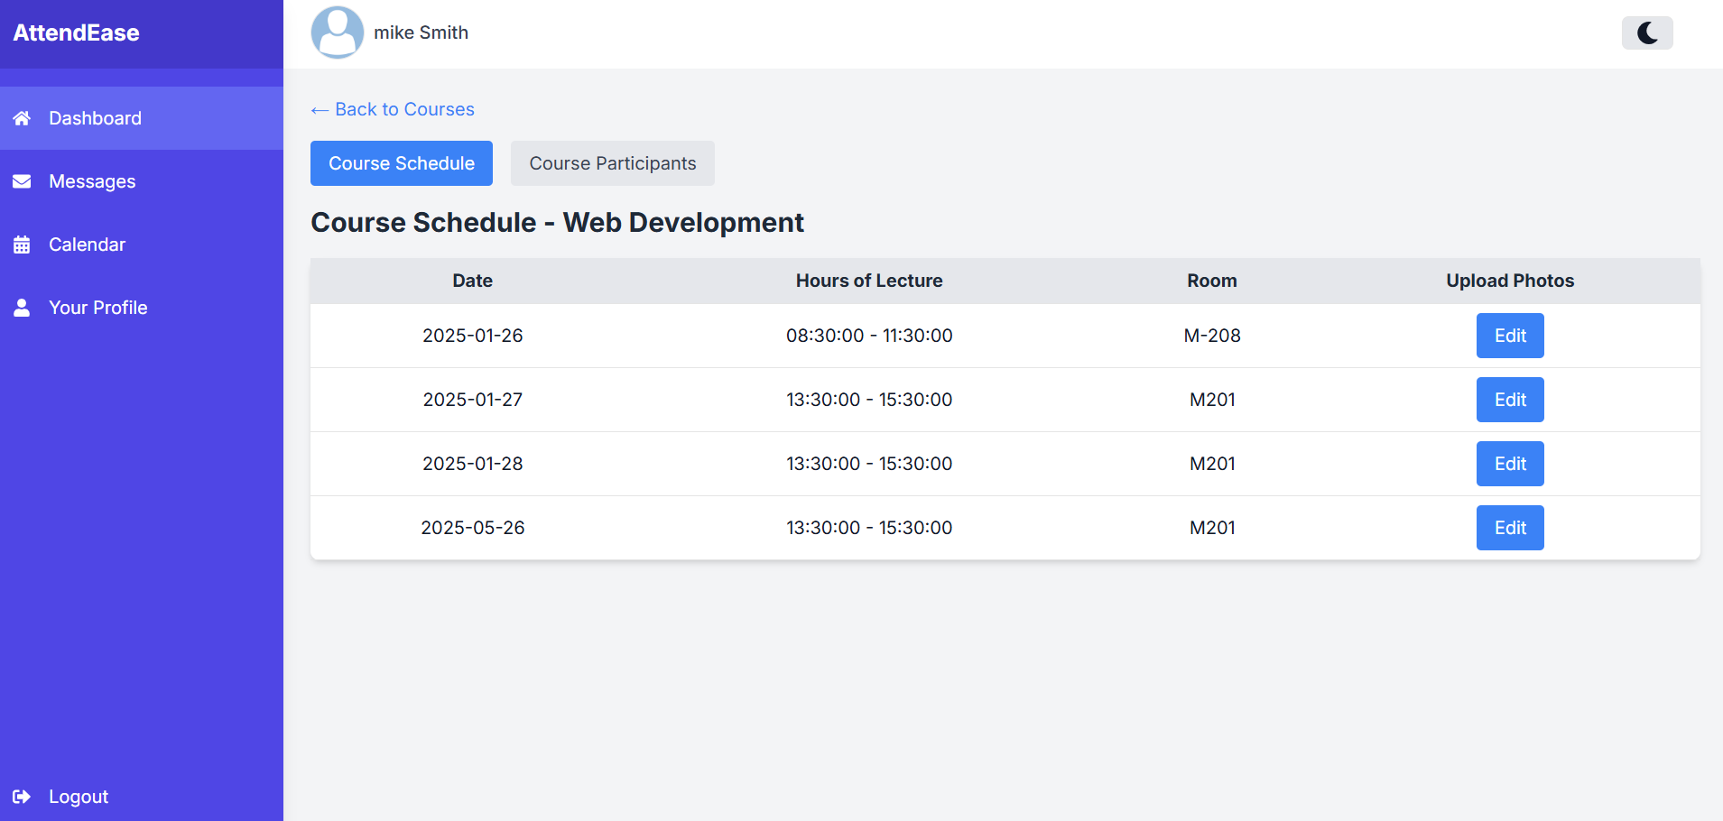

Clicking on the "Edit" button will open a window where the teacher can upload one or more class photos.
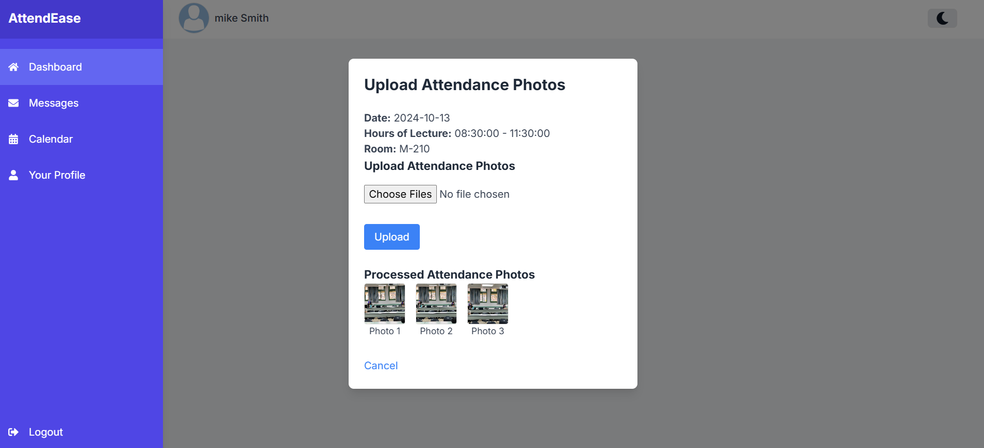

Once uploaded, the system will automatically:
- Detect faces in the photo using a face detection model.
- Recognize students by comparing detected faces with the student database.
- Mark attendance records based on recognized students.
- Visualize results by:
  - Drawing a square around each detected face in the processed photo.
  - Displaying the recognized student’s name above their face.

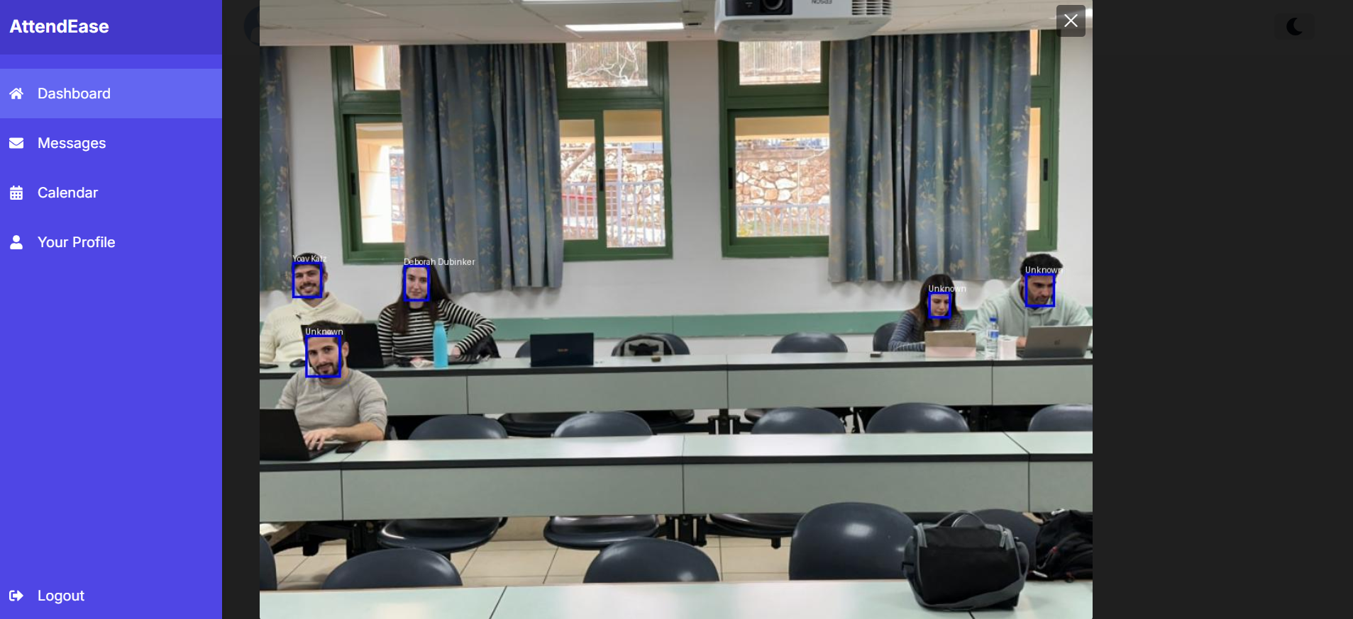

6.2.3 Course Participants Table – Teacher
The teacher can view a table with a list of all students in the course. In this table, each row represents a student, showing the following information:
- ID: The student's unique identification number.
- Name: The student's name.
- Attendance: The student's current attendance status for that course.
- Manual Edit: An option to manually edit the student's attendance if necessary. This allows the teacher to update the student’s attendance for any lecture.

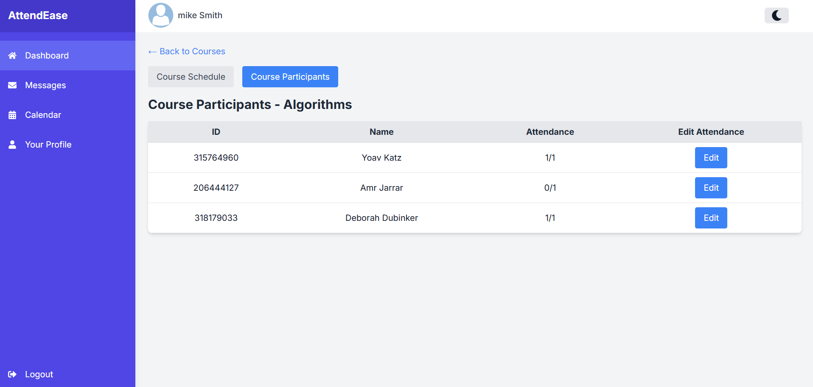

Clicking on the "Edit" button will open a window where the teacher can update the number of hours the student attended in the lecture.

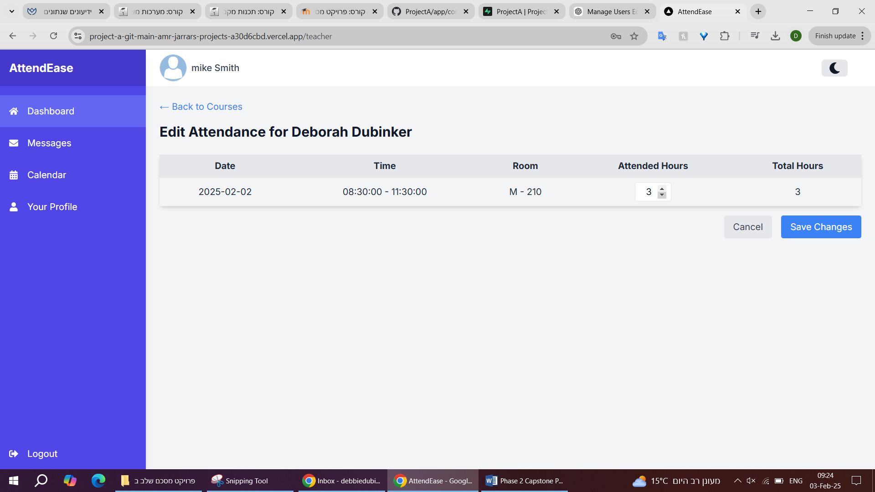

6.2.4 Messages
The Messages Tab allows students and teachers to securely communicate with each other regarding attendance and other related subjects. This section includes various folders to manage messages effectively:
- Inbox: Displays all received messages. Each message includes:
- From: The sender's name or email.
- To: The recipient's name or email.
- Title: The subject or title of the message.
- Content: The body of the message.
- Date: The date when the message was received.

- Send: Displays all messages that the user has sent. Contains the same information as the inbox (From, To, Title, Content, and Date).

- New Message: Allows users to compose and send new messages.

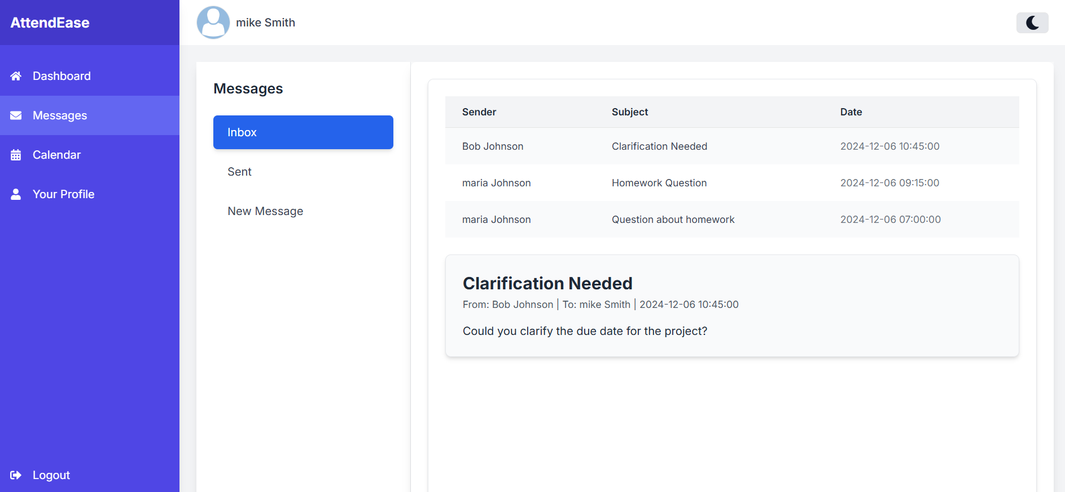

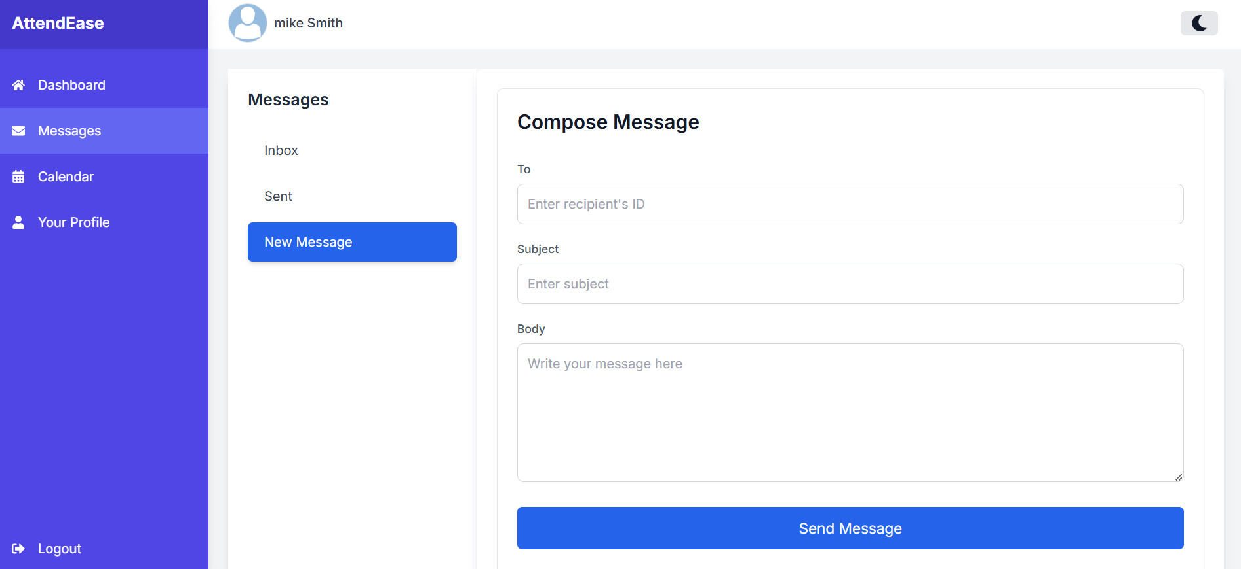

6.2.5 Calendar
- The Calendar tab provides an overview of all lectures scheduled for the courses a user is associated with.

  - Clicking on a date with scheduled lecture(s) displays the following details:
    - Lecture Name
    - Hours (time or duration)
    - Room (location where the lecture will be held)

  - If no lecture is scheduled for a selected date, a message will display: "No lectures for this day."

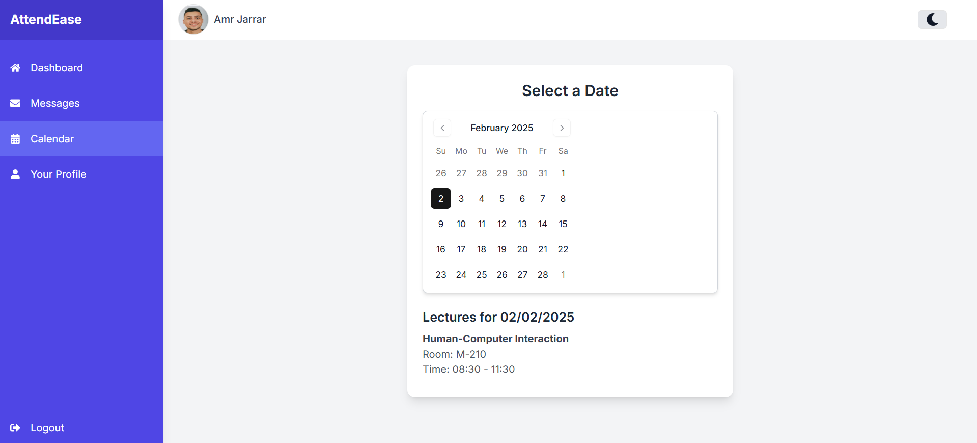

6.2.6 Profile
- The Profile tab allows users to view and manage their personal information.

- The following details are displayed in the profile:
- First Name
- Last Name
- ID
- Email Address
- Password

- Restrictions and Features:
- Not editable Fields: First Name, Last Name, ID and Email are view-only and cannot be changed by the user. These can only be updated by the administrator through the ‘Manage Users’ section in the Admin Dashboard.
- Editable Fields: Users can update their Password directly from the Profile tab.

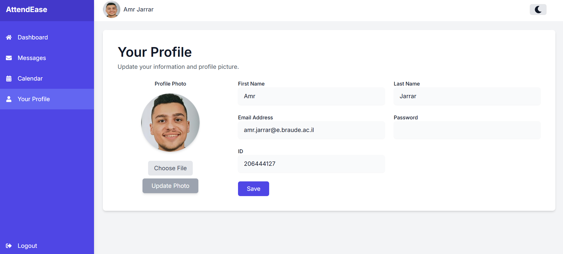

6.3 Administration Dashboard
- Once logged in, the administrator is directed to the Administrator Dashboard, where they can manage users and courses.

- Tabs in the Administrator Dashboard:
- Manage Users
- Manage Courses

6.3.1 Manage Users
- The administrator can manage users through three functionalities:
- Sign Up Individual User
The administrator can manually create a new user by entering the required details:
- First Name
- Last Name
- ID Number
- Role (Teacher, Student, Administrator)
- Email
- Password
- Profile Photo

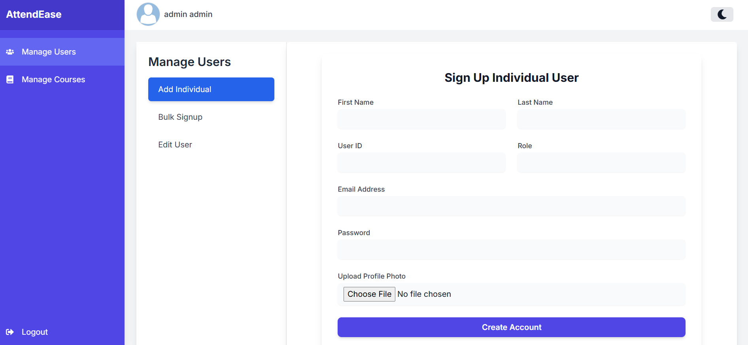

- Bulk Signup
The administrator can upload an Excel file to add multiple users at once. The file must include the required fields for each user.

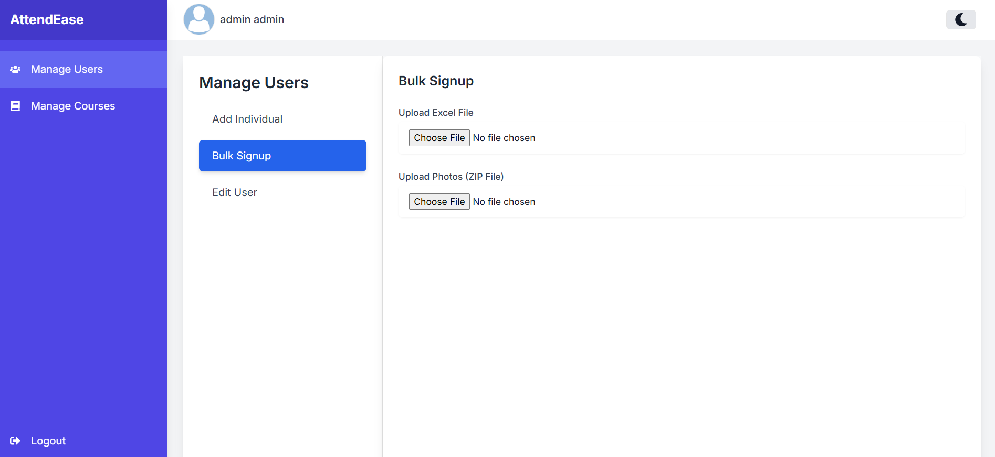

- Edit User
The administrator can search for a user by ID number and update their details as needed.
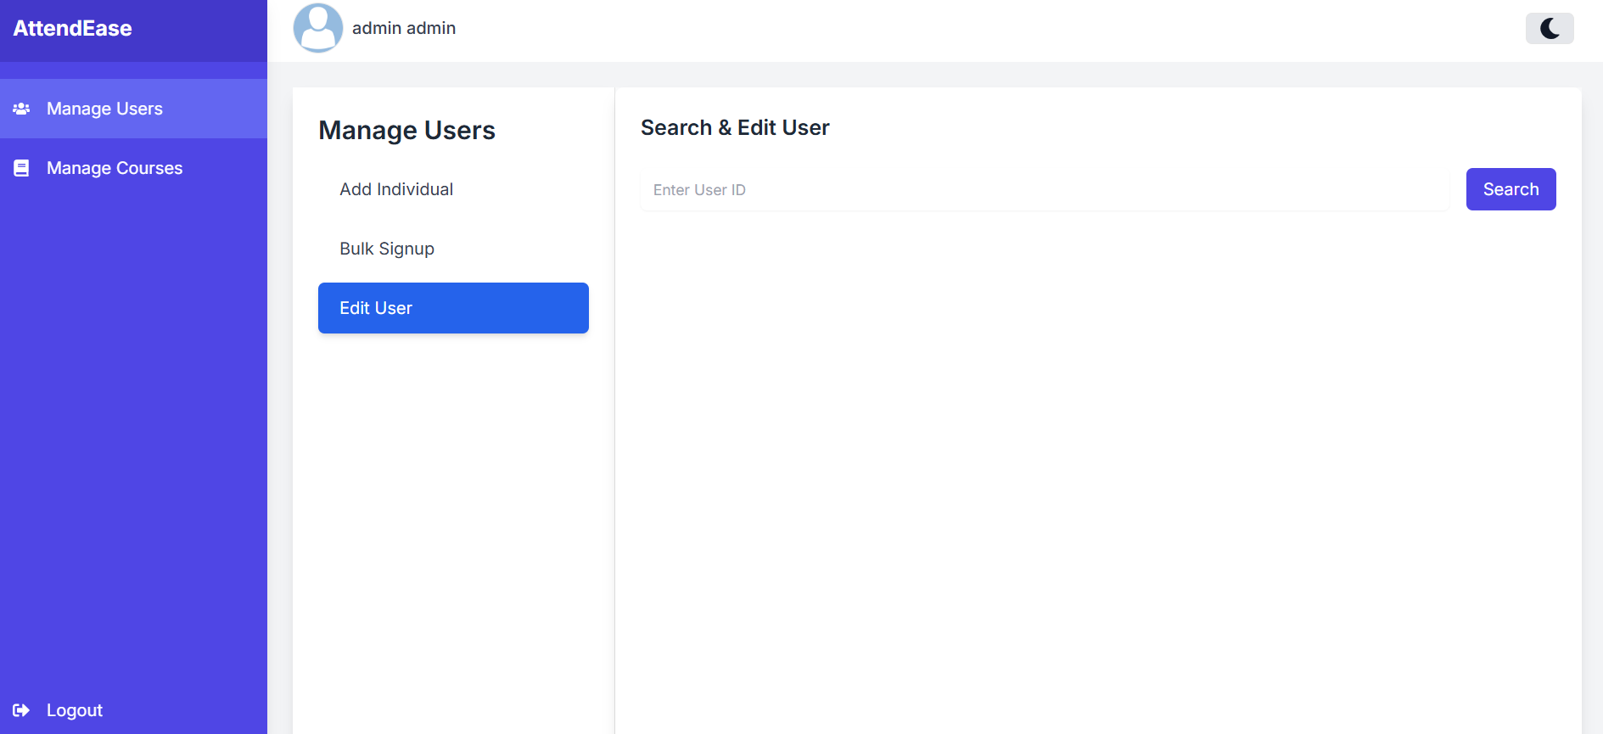

6.3.2 Manage Courses
- The Course Management tab enables administrators to view and manage all courses in the institute. Key functionalities include:
- Switch Year and Semester: Navigate between different academic years and semesters.
- Search: Find specific courses by name within the selected year and semester.

- For each course, the following details are displayed:
- Course Name
- Course Code
- Year
- Semester

- Available actions for each course:
- Edit Details: Displays detailed information about the course and allows editing it, including:
  - Course name, code, year, and semester.
  - Teachers teaching the course.
  - Students enrolled in the course.
  - Session in the course.
- Delete: Permanently removes the course from the system.

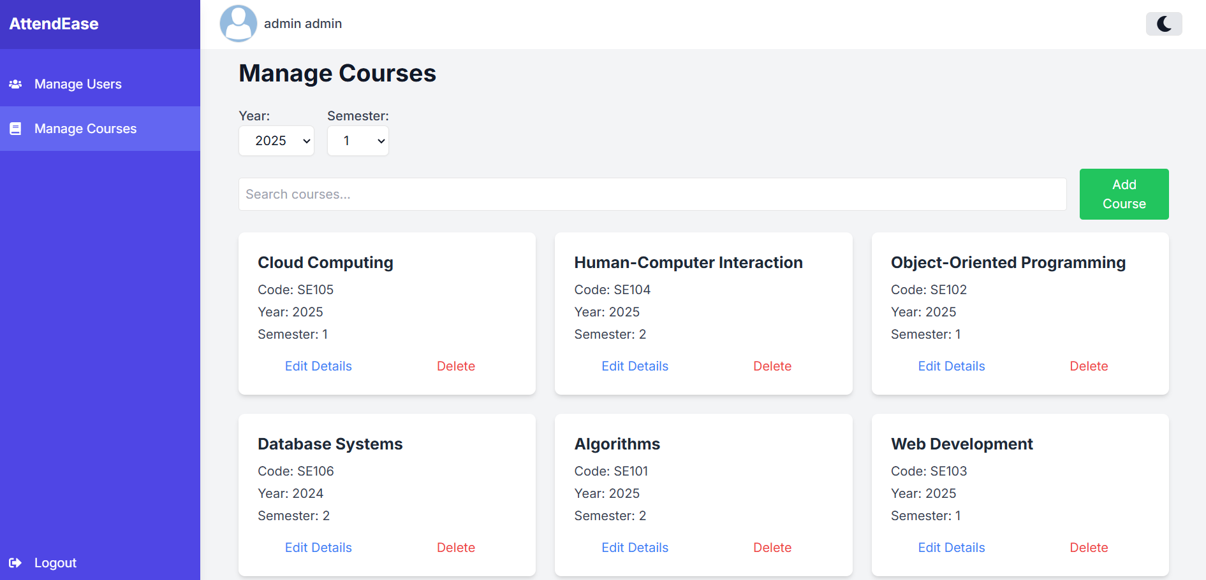

Clicking on the "Edit Details" button will open a window where the admin can see detailed information about the course and edit it.

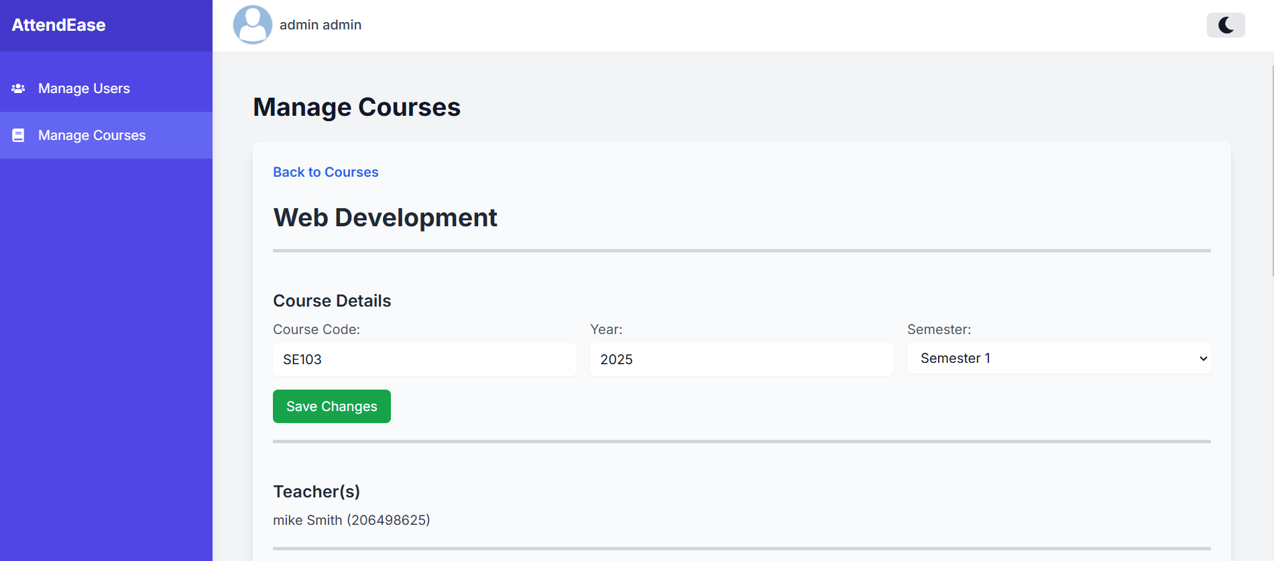
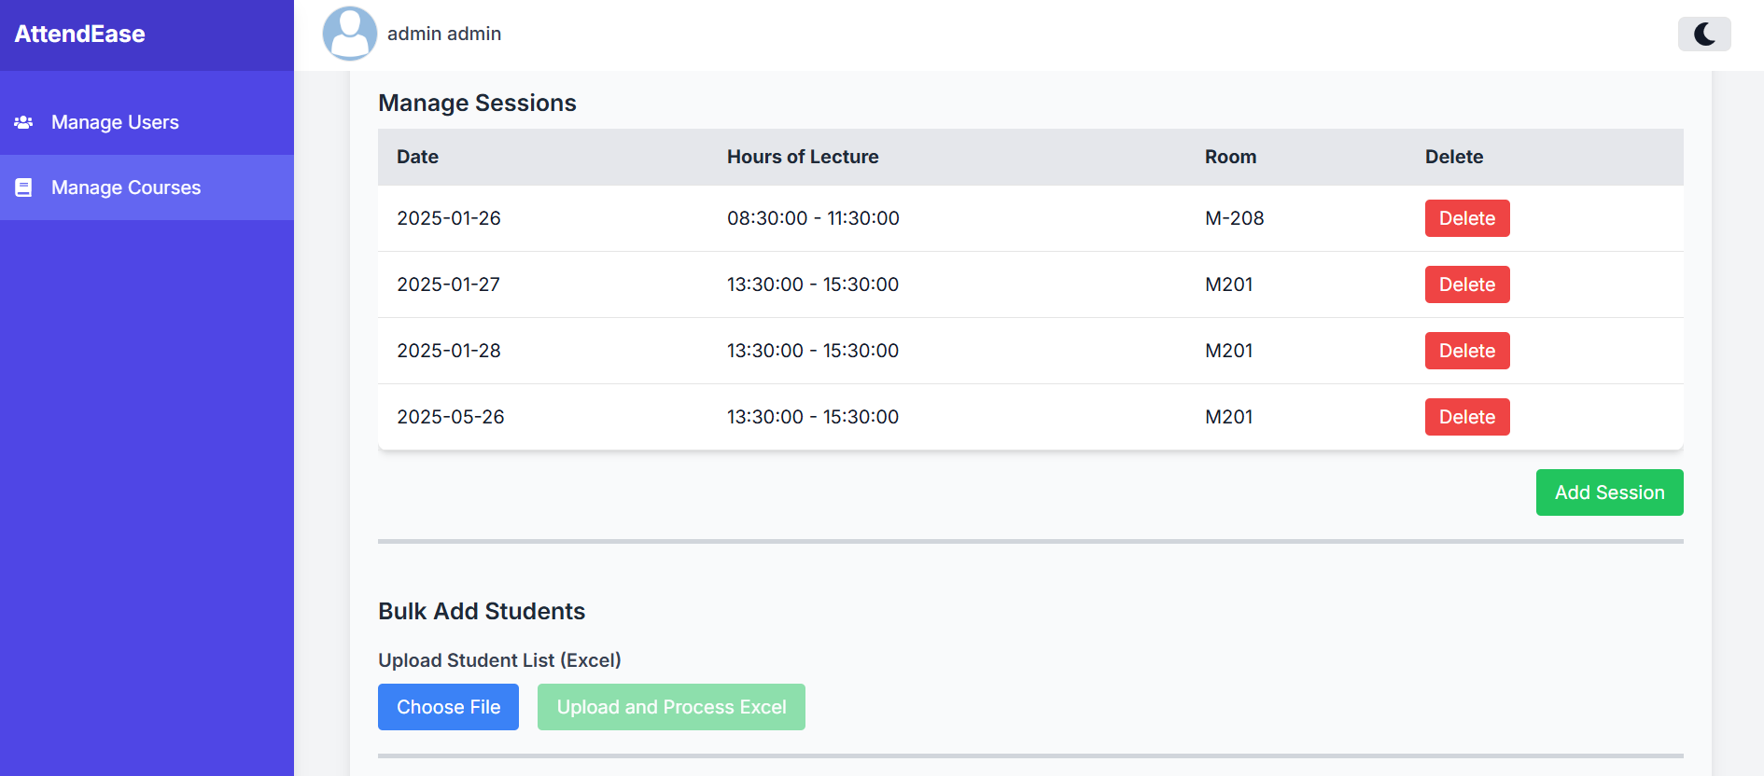
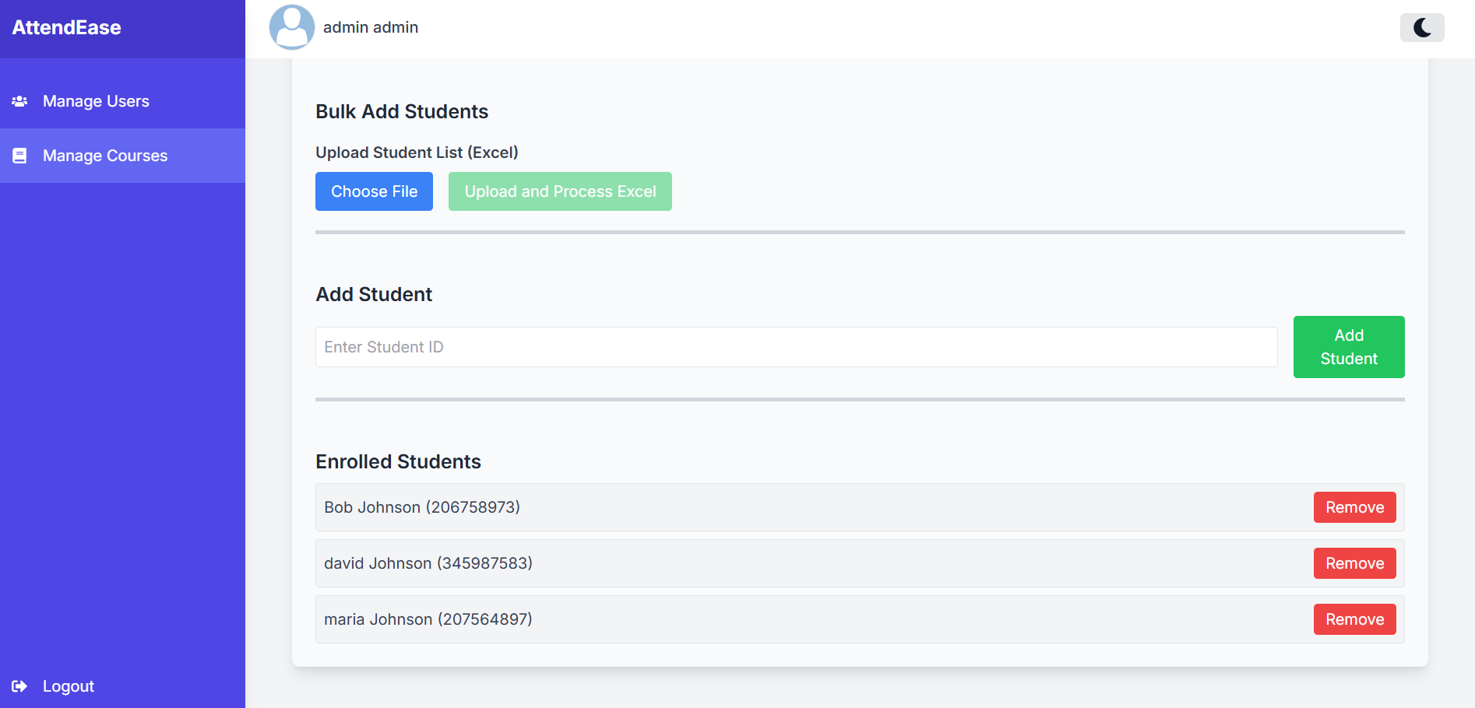

Chapter 7

Maintenance Guide

7.1 Link to GitHub
https://github.com/Jarrar7/ProjectA/

7.2 Installation
- Cloning the Repository: To set up the system locally, clone the repository using the following command:

git clone https://github.com/Jarrar7/ProjectA.git
cd ProjectA

- Installing Dependencies: After cloning the repository, install the necessary dependencies using npm or yarn:

npm install

Or if using yarn:

yarn install

- Setting Up Environment Variables: The project requires environment variables to connect to external services, including Supabase and the API service.
Create a .env.local file in the root directory and add the following variables:

NEXT_PUBLIC_SUPABASE_URL=<your_supabase_url>
NEXT_PUBLIC_SUPABASE_ANON_KEY=<your_supabase_anon_key>
NEXT_PUBLIC_API_URL=<your_api_url>
SUPABASE_SERVICE_ROLE_KEY=<your_supabase_service_role_key>

Note: Replace <your_supabase_url>, <your_supabase_anon_key>, your_api_url> and <your_supabase_service_role_key> with actual credentials.

- Running the Application Locally: Once dependencies are installed, start the development server:

npm run dev

Or:

yarn dev

- The application will be accessible at: http://localhost:3000.

7.3 Running the Flask-Based Face Recognition Service
The face recognition API runs separately using Flask. To set it up:
- Install Python Dependencies: Navigate to the flask_api directory and install dependencies:

cd flask_api
pip install -r requirements.txt

- Start the Flask Server: Run the Flask server to handle image processing requests:

python app.py

- The API will be accessible at: http://localhost:5000
Ensure this server is running when testing face recognition.

https://github.com/Jarrar7/flask-face-recognition.git

7.4 Libraries and Tools
- Frontend
- React: Library for building user interfaces.
- Next.js: Framework for server-side rendering and static site generation.
- Tailwind CSS: Utility-first CSS framework for styling.

- Backend
- Next.js API Routes: Handles authentication, attendance tracking, and database interactions.
- Supabase: Backend-as-a-service for authentication and database management.
- Flask: Python framework for the face recognition API.

- Face Recognition
- MTCNN – Face detection model used in the recognition pipeline.
- FaceNet – Deep learning model for face recognition.

- Other Tools
- XLSX: Library for reading and writing Excel files.

References

Chapter 2 – Existing Tool:
- irisid.com
- teacherkit.net
- classter.com

Chapter 2 – Literature Review:
- Ross, A., Nandakumar, K., & Jain, A. K. (2006). "Handbook of Multibiometrics."
- Jain, A. K., & Ross, A. (2008). "Introduction to Biometrics."
- Zhao, W., Chellappa, R., Phillips, P. J., & Rosenfeld, A. (2003). "Face Recognition: A Literature Survey."

